# Week 2: Hands-on Lab

**Question 1:** Were there any warnings loading data into the JOBS table? What can

be done to resolve this?

Hint: View the data loaded into this table and pay close attention to the JOB_TITLE

column.

**Answer 1:** Yes. The warning messages are listed as follows:

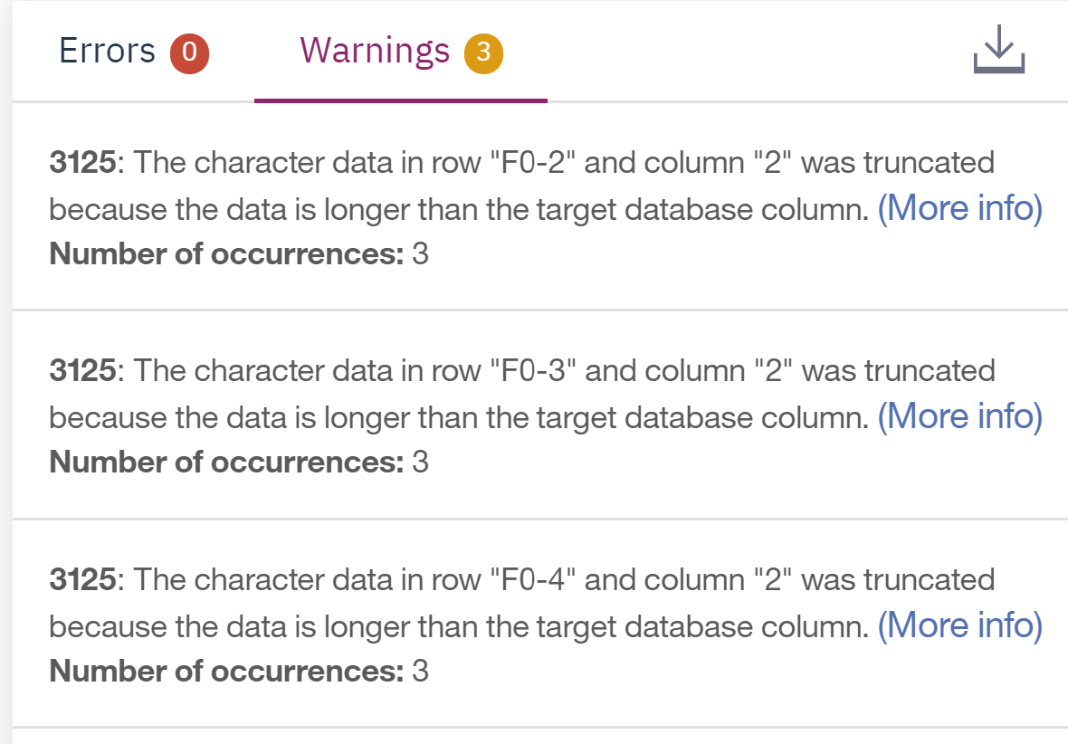

The character length of JOB_TITLE in Rows 2, 3, 4 is longer than 15, the defined character length of column JOB_TITLE.

We need to expand the character length of target columns when define JOBS table.

**Question 2:** Did all rows from the source file load successfully in the DEPARTMENT

table? If not, are you able to figure out why not?

Hint: Look at the warning. Also, note the Primary Key for this table.

**Answer 1: The warning message is:**

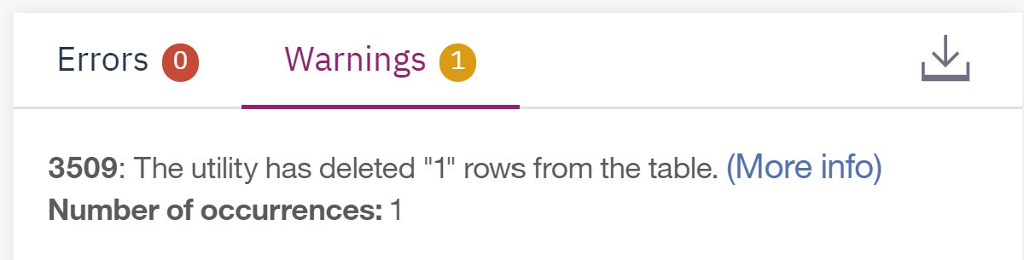

The PRIMARY KEY of the table DEPARTMENTS is DEPT_ID_DEP, thus the values of DEPT_ID_DEP must identify the rows uniquely. 主键必须能够唯一标识所有的行.

